Verify patching updates in MECM aka SCCM. We automated and detailed it out for the security patches to be downloaded as well as scheduled deployments for Pilot, CommV/Monitoring and SCCM. What is needed to be done, is to verify the updates are there.

* Mm-rds-a02, ADM credentials
* Microsoft Endpoint Configuration Manager
* Corp: mp-scm-a01.corp.net.bcbsaz.com
* Server Security Patches – July 2023

Software Library/Software Updates/Software Update Groups, locate Server Security Patches – July 2023

* Using June as an example:

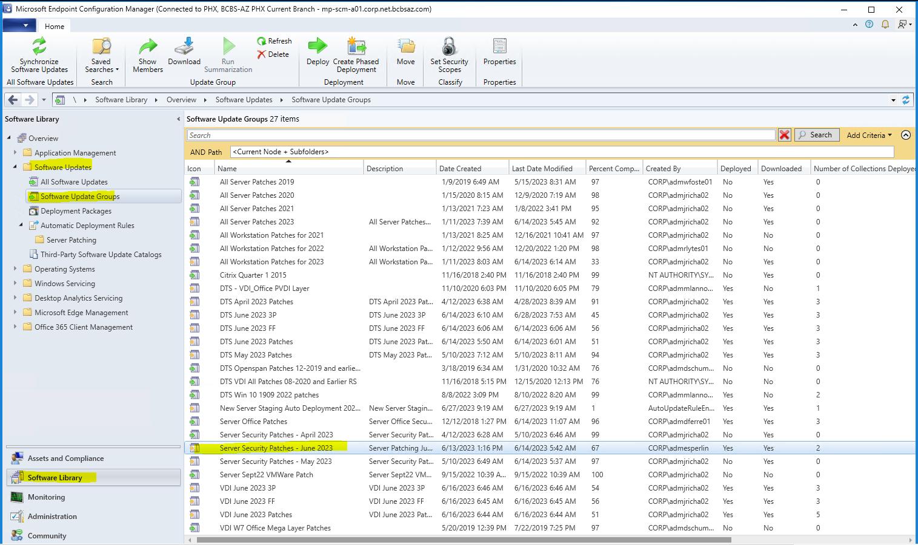

* *The group for July will not be created till 7/11*, using June as an example, you will only be checking if the updates are there and downloaded.
* Double click on the group, it will open to reveal the patching updates.

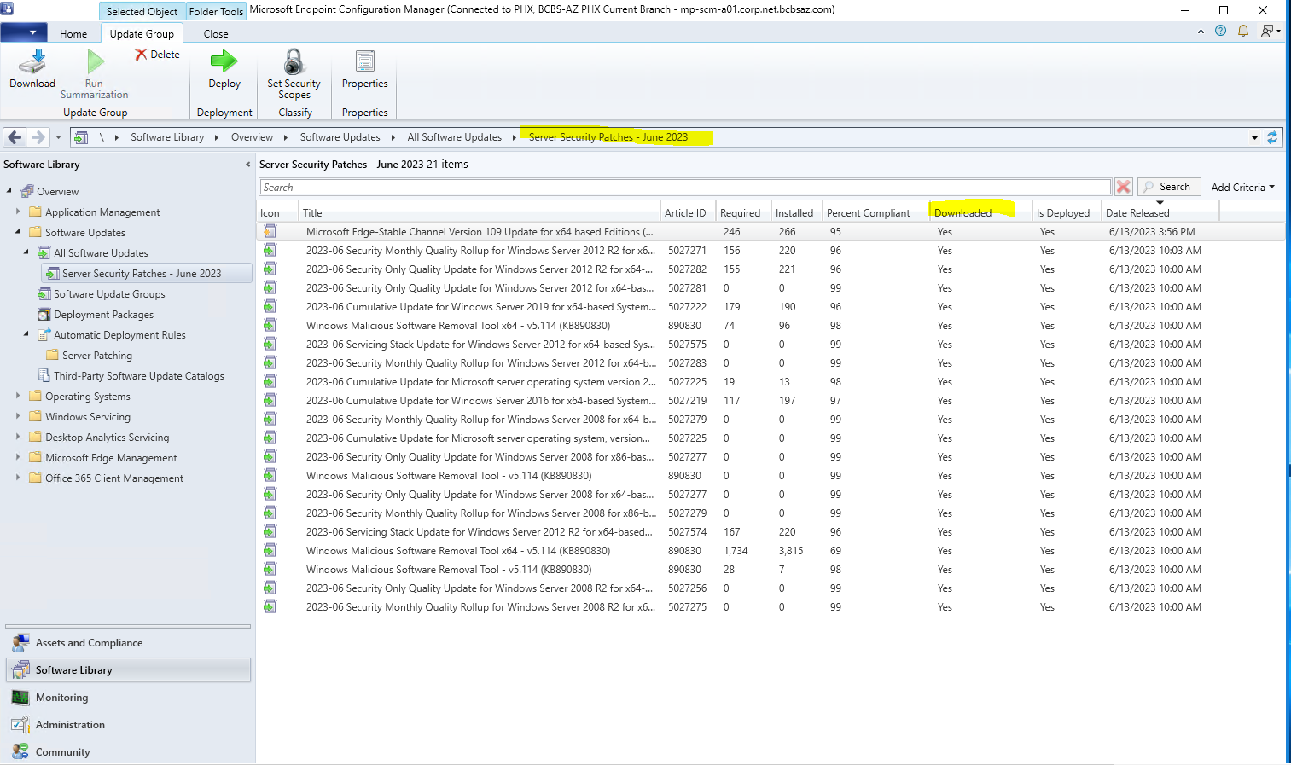

The automation policy:

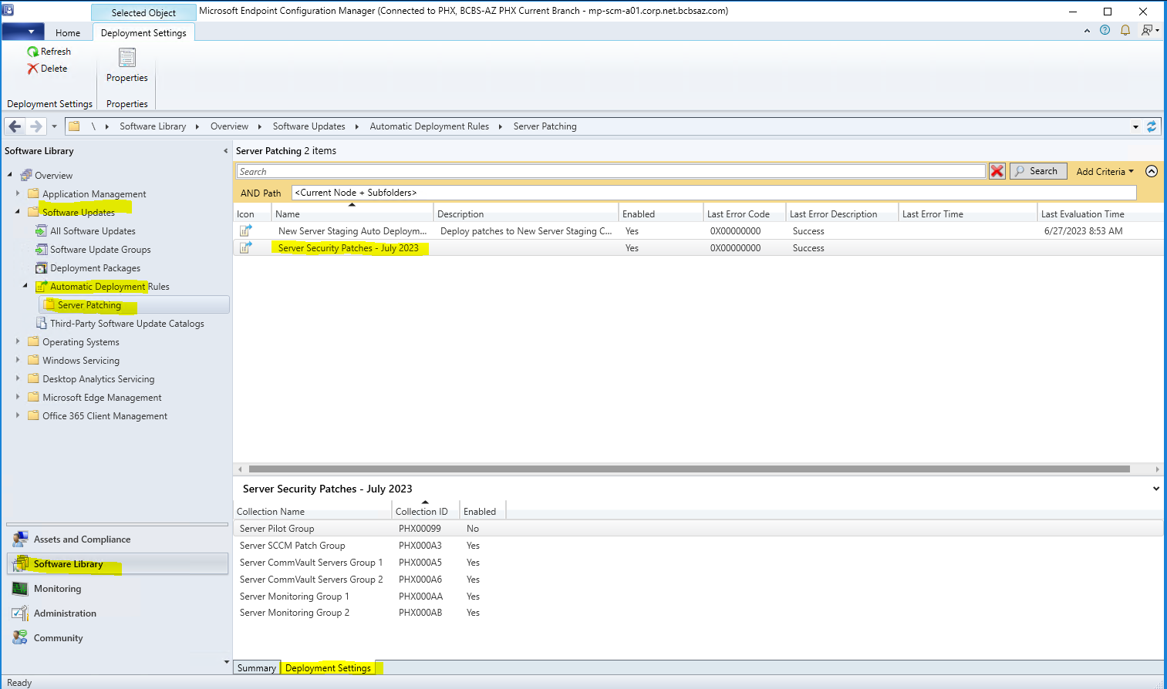

* Software Library/Software Updates/Automatic Deployment Rules/Server Patching/Server Security Patches – July 2023/Deployment Settings Tab